FINANCIAL STATEMENT 2020

- MAY 2020:
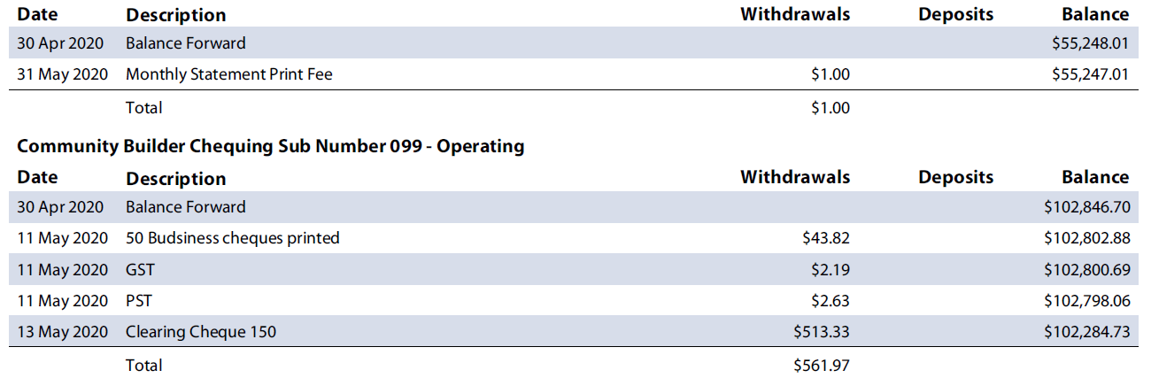
- JUNE 2020:
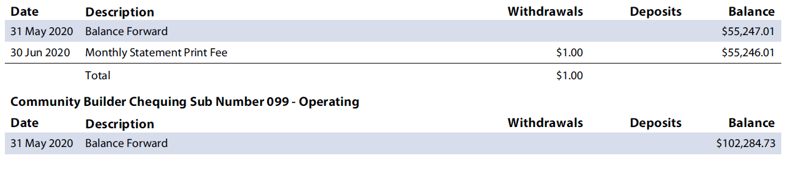
- JULY 2020:
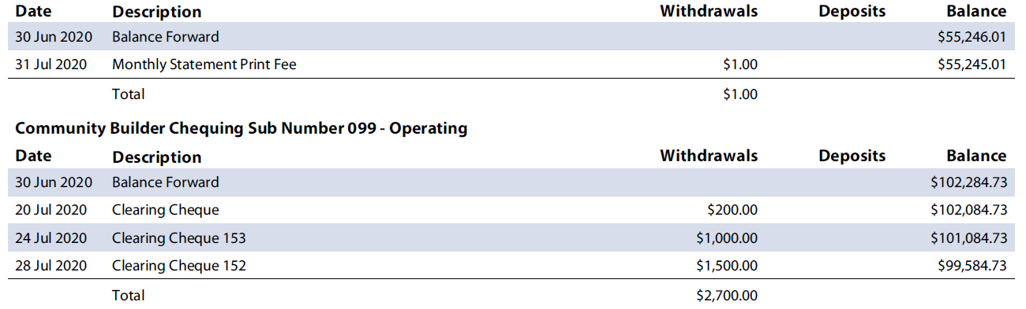

- AUGUST 2020:
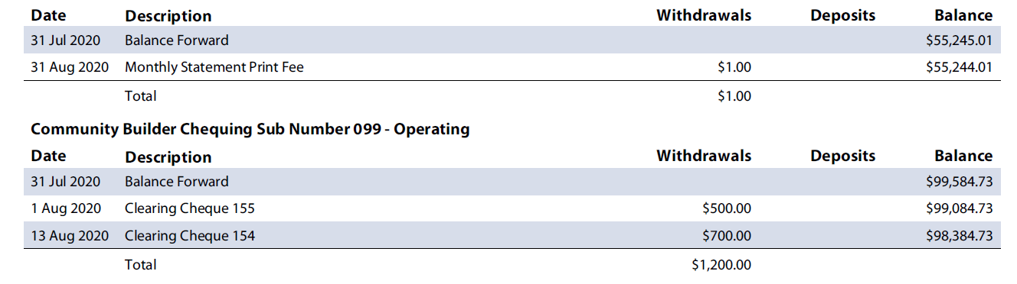

- SEPTEMBER 2020:
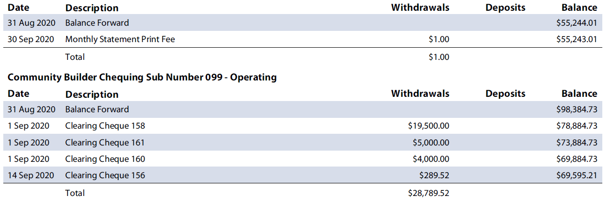
- OCTOBER 2020:
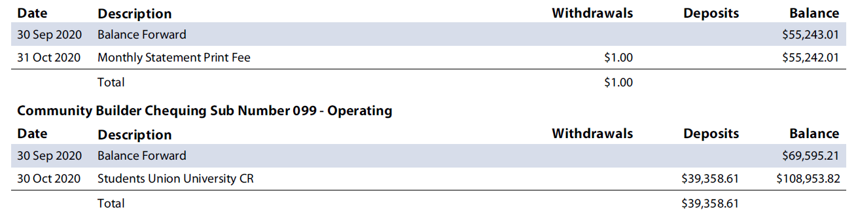

- November 2020:
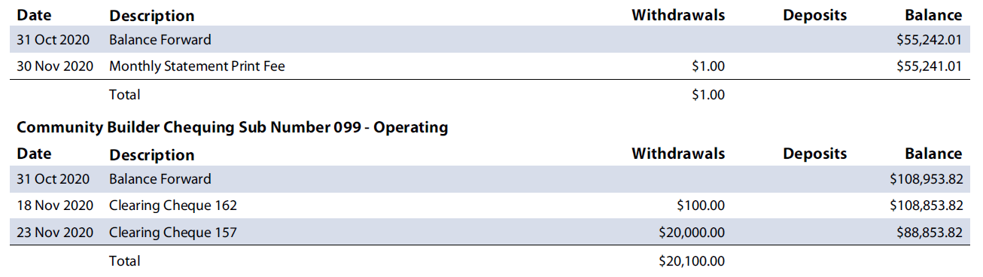
- December 2020:

